Website Design Slicing

Fleet Lease Website

# SEction A – Introduction

## 1. Introduction

Athena IT Limited is seeking to slice **website designs** into **code**

## 2. Business

The purpose of this website is to make it possible to **provide manual valuations** on cars entered by **Fleet** and **Leasing partners**

## 3. Scope

* There are **16 page designs** to slice into code
  + Across **two designs (“Maxxia” & “RemServ”)**, with broadly the same layout
    - **Each design** consists of:
      * 6 user interface pages
  + There is a **shared administration panel**:
    - 4 administrator pages

## 4. Provided Resources

* You have been provided with:
  + **Wireframes *(Password: FLVF)***
    - **Maxxia -** <https://augjwf.axshare.com/#p=vehicle_selection>
    - **RemServ -** <https://augjwf.axshare.com/#p=vehicle_selection__remserv_>
  + **Corporate Style Guides**
    - **Maxxia** *(attached)* 
      * **Page references of include:** page 21
    - **RemServ** *(attached)*
      * **Page references of note include:** page 40

## 5. Intent

* The wireframes are intended to **provide context** and the **overall layout**
* When implementing the **wireframes** you will need to implement them subject to the **corporate style for each brand**, this includes, but is not limited to:
  + Buttons
  + Fonts
  + Logos
  + Colours
  + Input boxes
  + Icon Usage

## 6. Discrepancy

Where there is a discrepancy during development between the written section of a component and a wireframe, the written component will take precedence

## 7. Browser Compatibility

Below, the browser scope inclusions for this project is listed:

**Where a browser exists for Windows and MacOS, the following desktop platforms are included:**

* Internet Explorer 9, 10, 11
* Edge (Latest Version)
* Firefox (Latest Version)
* Chrome (Latest Version)
* Safari (Latest Version)

**Mobile Platforms (Using the Latest OS & Chrome/Safari as applicable)**

* iPhone 6, 6+, 7, 7+, 8, 8+, X (responsive)
* iPad (Latest) (responsive)
* Samsung Galaxy 7, 8, 9 (responsive)
* Surface (responsive)

**Misc**

* **Layout Style:** Fixed-width maximum, responsive on smaller displays
* **Target screen resolution:** 1024 x 768
* **Favicon:** Yes
* Design to operate in a standard operating environment, with graceful degradation

## 8. Responsive Behaviour

* As a screen gets smaller the website shall:
  + Swap to tablet mode at a resolution lower than 1024px width or when a tablet device is detected
  + Swap to a mobile mode when the resolution is smaller than 640px or when a mobile device is detected
* The website shall support both portrait and landscape mode on a tablet, but only portrait mode on a mobile
* On desktops larger than 1024 wide, the layout will be centrally positioned, with the background elements and colours expanding horizontally to fill the space
* Content shall be scaled automatically to the most appropriate size wherever possible

## 9. Scrolling

* Vertical scrolling only on mobile & desktop

## 10. Frontend Technology

* HTML5
* Bootstrap
* SASS
* Webpack
* jQuery
* Flexbox
* NPM

## 11. Deliverables

* It is important to be able to retain corporate styles (including colours, logos and fonts) through single CSS (or in case it is not possible SAAS) file in a way that we can add a new brand or update an existing one without rebuilding assets
* All assets should be sliced into:
  + Page templates
  + Sections for specific content
* There has to be **a single HTML source** for all pages and all branding **has to be done** through separate CSS (or in case it is not possible SAAS) file

## 12. Compliance & Speed Testing Requirements

* [**WCAG Compliance**](https://www.w3.org/WAI/standards-guidelines/wcag/)**:** Yes (Rating AA)
* [**GTMetrix**](https://gtmetrix.com/)**:** Grade A
* [**Google Page Speed**](https://developers.google.com/speed/pagespeed/insights/)**:** Above 90%

## 13. Integration Responsibility

* This specification confers **no responsibility** for integrating the produced website design code into the platform that we have built

## 14. Input/Error Handling

* Conforming to the style guides, input/error handling message examples for input/drop down menus should be able to be used on each page

## 15. Design Narrative

* A common layout is shared between the Maxxia and RemServ designs, the differences are limited to brand personalities
* In the wireframe descriptions below
  + Narratives are provided for the Maxxia brand, the same intent will apply to the RemServ corporate style guide – make inferences using the narrative provided
  + For each wireframe descriptions have been provided once for an object or set of objects, in the proceeding wireframes it is intended for you to infer that the treatment will be the same as those described above

# Section B – Design Narrative

## 1. Vehicle Selection

1.2

1.1

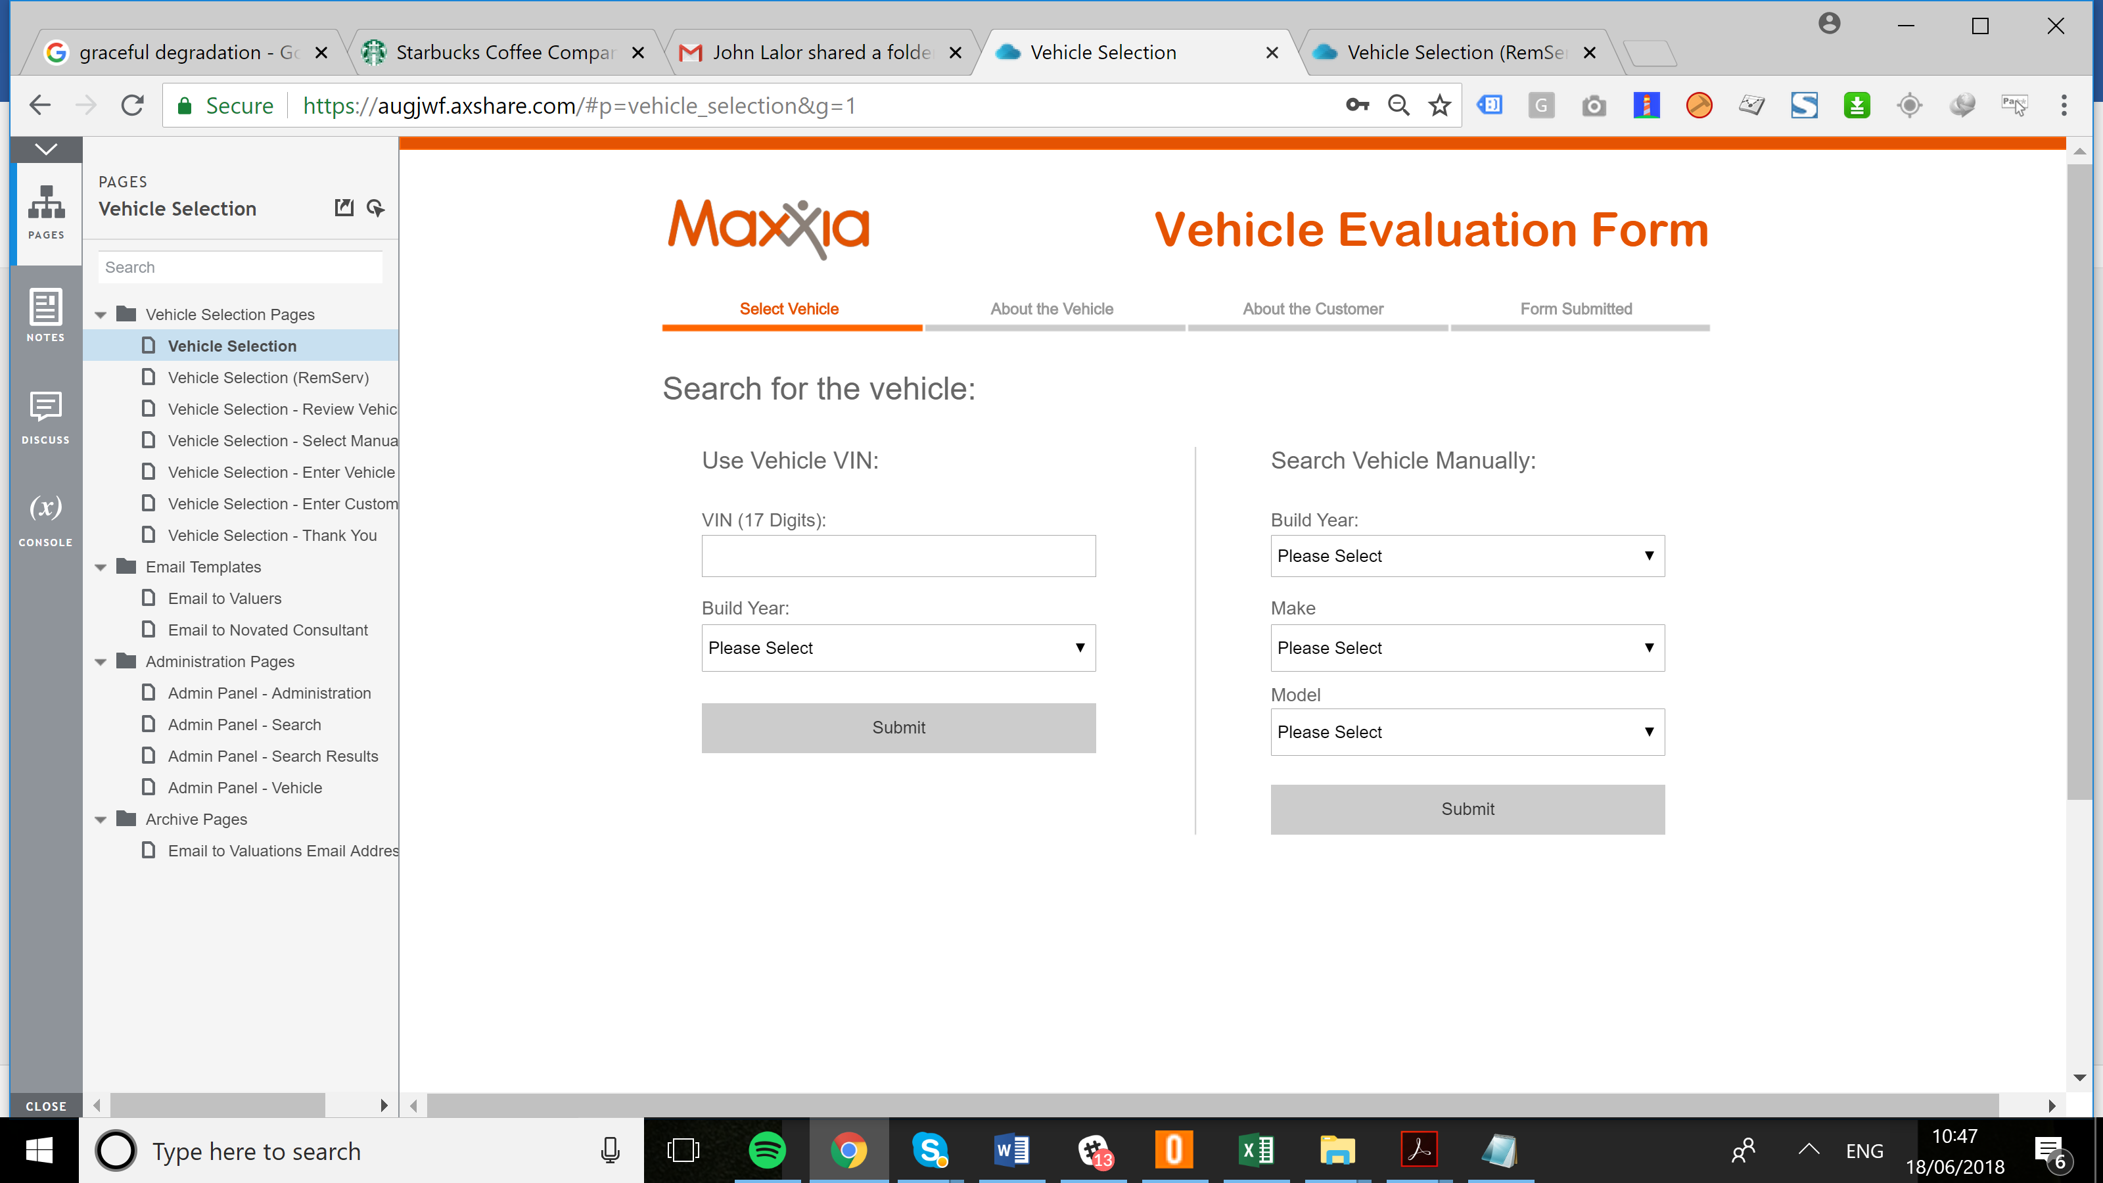

1.4

1.3

1.5

**Page**  
  
<https://augjwf.axshare.com/#p=vehicle_selection__remserv_&g=1>   
<https://augjwf.axshare.com/#p=vehicle_selection&g=1>

### Maxxia Logo

* Requirements for the Maxxia logo are described on **pages 6 & 7** of the corporate style guide
* Clicking on this link should return to the “Vehicle Selection” page

### Text

* Requirements for the Maxxia fonts are described on **pages 13 & 14**

|  |  |
| --- | --- |
| Header 1 <h1> | Search for the Vehicle |
| Header2 <h2> | Vehicle Evaluation Form |
| Header3 <h3> | Use Vehicle VIN, Search Vehicle Manually |
| Title <title> | Maxxia – Vehicle Evaluation Form |

### 1.3 Progress Bar

* The progress bar will be subject to the Corporate Style Guide’s use of colours **page 54** andfonts, **page 13 & 14**

### 1.4 Inputs

* As per page 40, Maxxia have already stylised inputs and drop down menus, please use the handling & styles provided

### 1.5 Buttons

* As per **page 40**, Maxxia have already buttons as per **page 44**, please use the handling & styles provided

### 1.6 Mast Head & Footer

* As per page 40 & 45, Maxxia make use of a Mast Head & Footer, please use the handling & styles provided

## 2. Review Vehicle

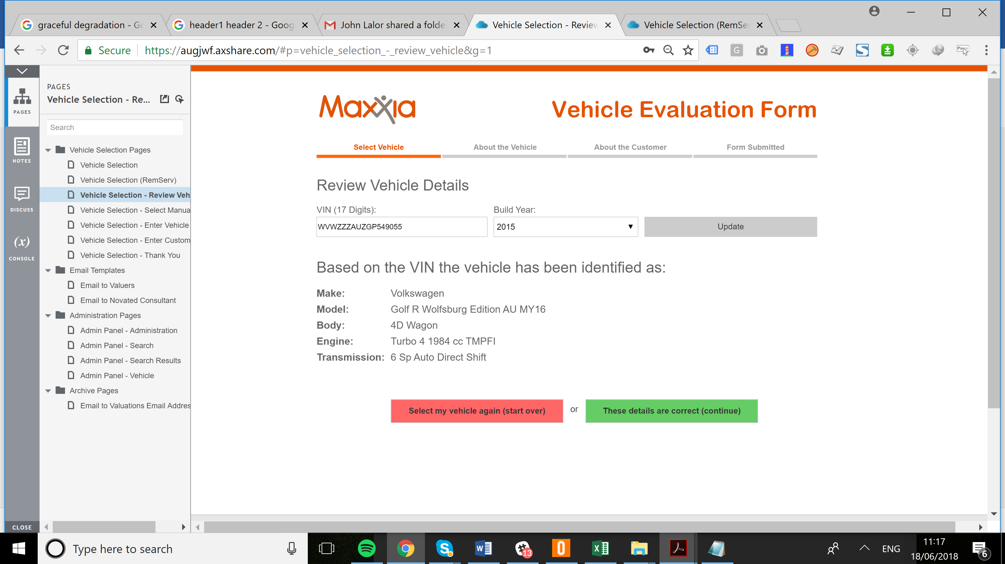

2.2

2.3

**Page**  
  
<https://augjwf.axshare.com/#p=vehicle_selection_-_review_vehicle&g=1>

### 2.1 Text

* Requirements for the Maxxia fonts are described on **pages 13 & 14**

|  |  |
| --- | --- |
| Header 1 <h1> | Review Vehicle Details |
| Header2 <h2> | Vehicle Evaluation Form |
| Header3 <h3> | Based on the VIN the vehicle has been identified as: |
| Title <title> | Maxxia – Review Vehicle Details |

### 2.2 Buttons

* As per page 40, Maxxia have already buttons as per **page 44**, please use the handling & styles provided
* The style guide allows for the following treatment types:

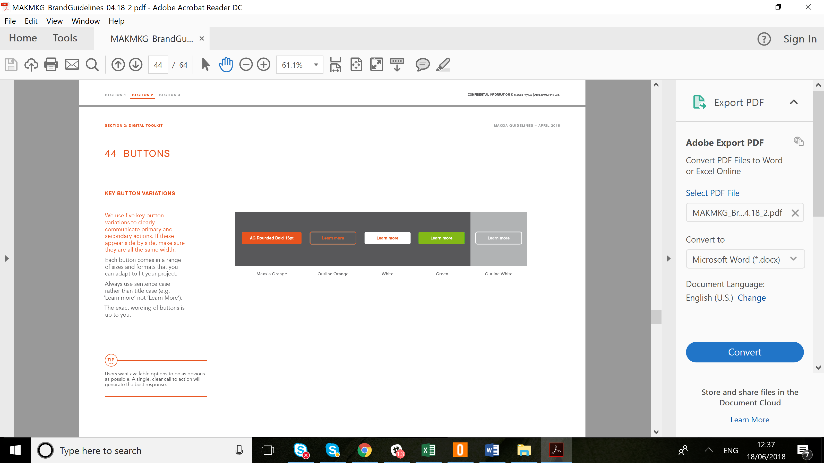

* Button Selection

|  |  |
| --- | --- |
| Text On Button | Button Selection |
| Select my vehicle again (start over) |  |
| These details are correct (continue) |  |
| Update |  |

### 2.3 Table

* This is a table of data

## 3. Select Manually

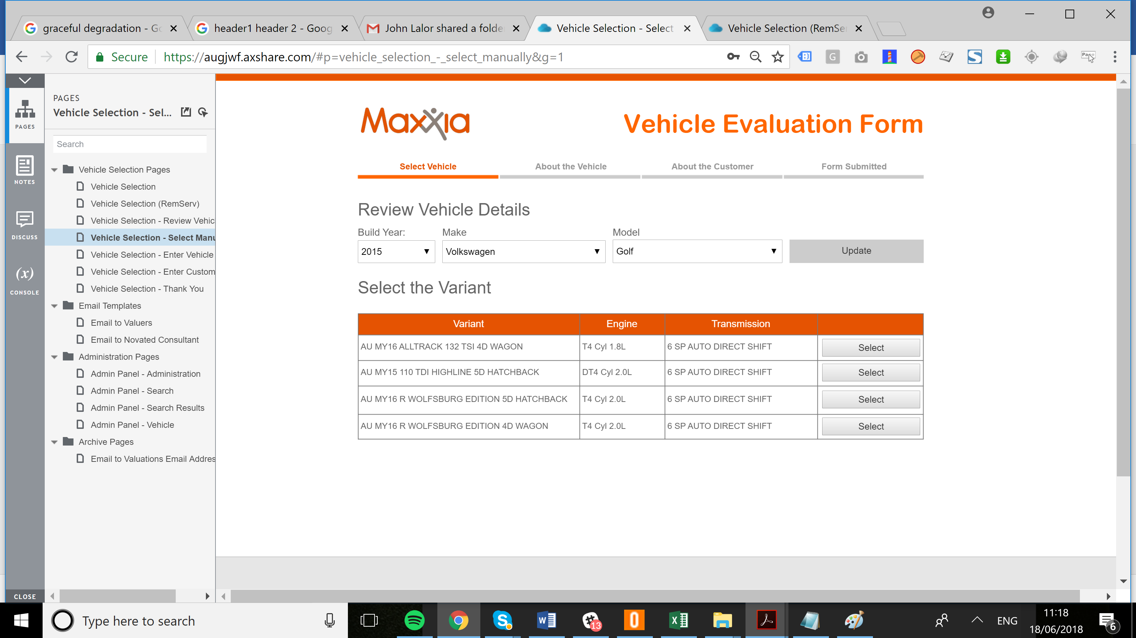

3.2

3.3

**Page**  
  
<https://augjwf.axshare.com/#p=vehicle_selection_-_select_manually&g=1>

### 3.1 Text

* Requirements for the Maxxia fonts are described on **pages 13 & 14**

|  |  |
| --- | --- |
| Header 1 <h1> | Review Vehicle Details |
| Header2 <h2> | Vehicle Evaluation Form |
| Header3 <h3> | Select the Variant |
| Title <title> | Maxxia – Review Vehicle Details - Manual |

### 3.2 Table

* This will be a table of generated data from the backend

### 3.3 Buttons

* For “Select” use Maxxia Orange



## 4. Enter Vehicle

3.3

3.3

**Page**  
  
<https://augjwf.axshare.com/#p=vehicle_selection_-_select_manually&g=1>

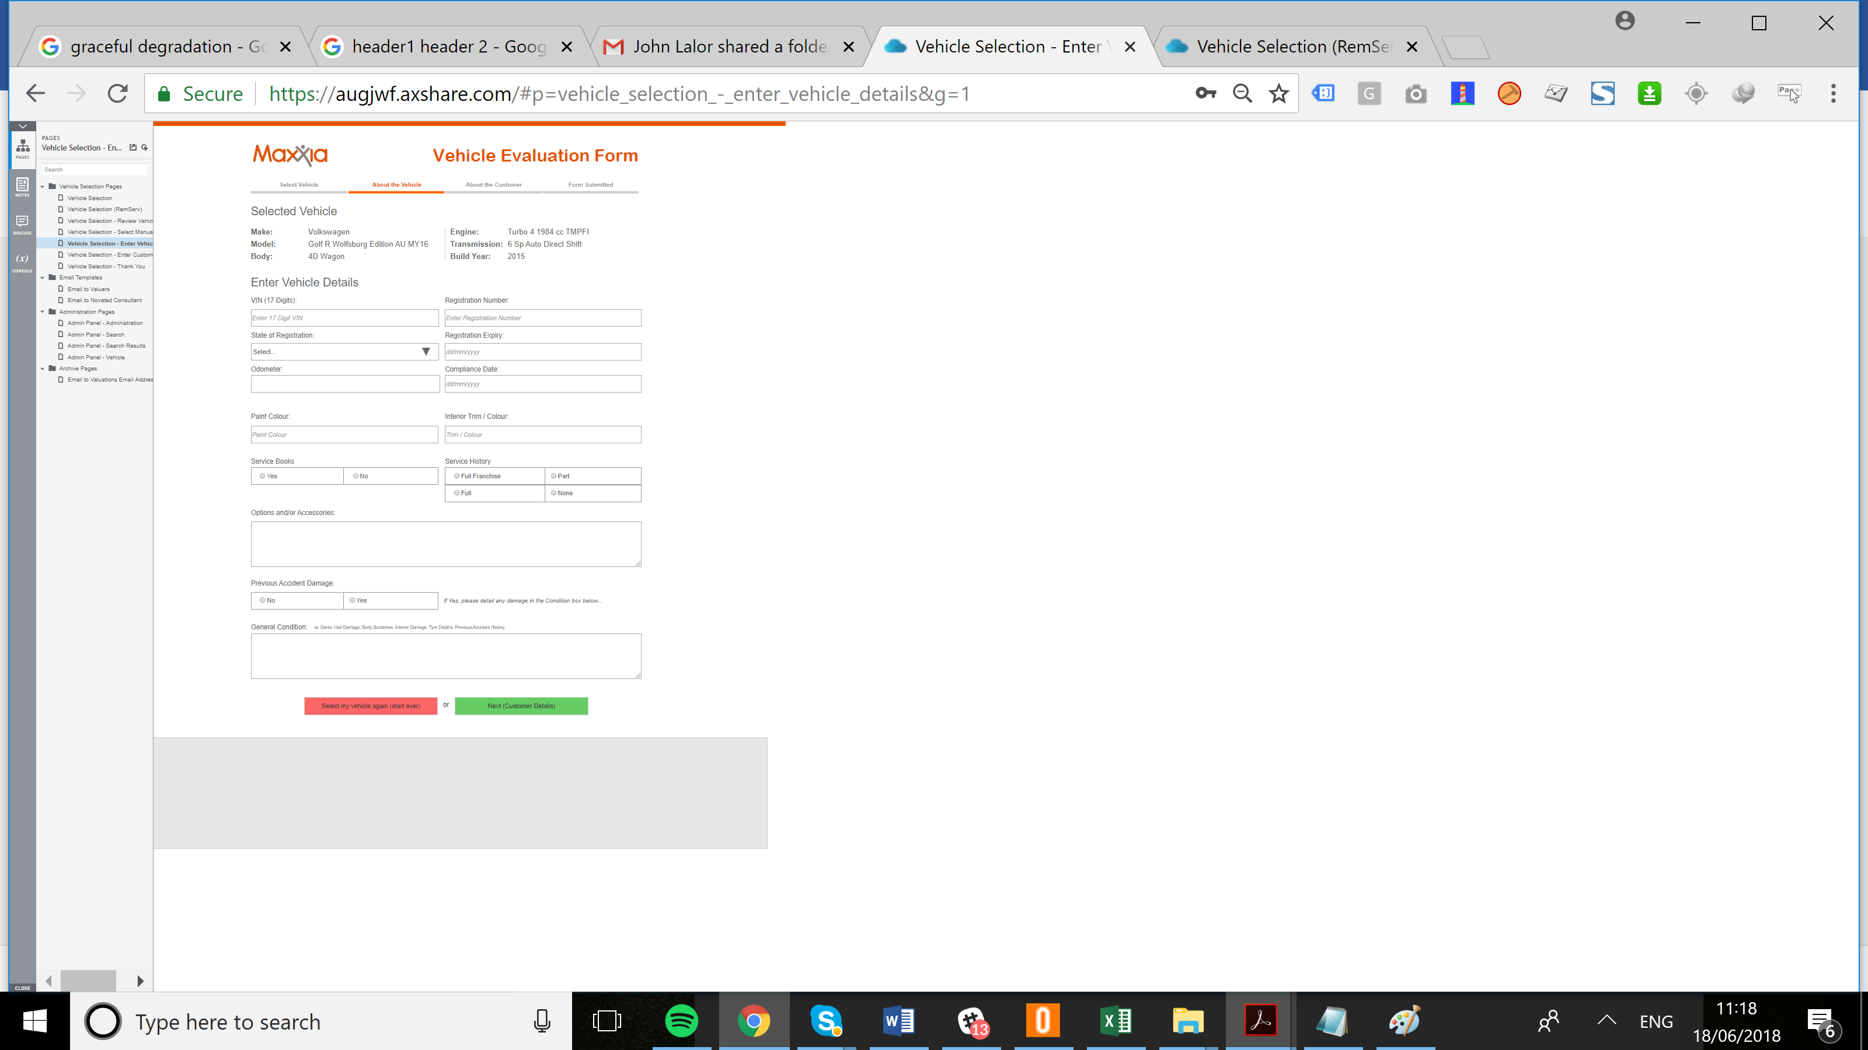

### 4.1 Text

* Requirements for the Maxxia fonts are described on **pages 13 & 14**

|  |  |
| --- | --- |
| Header 1 <h1> | Selected Vehicle |
| Header2 <h2> | Vehicle Evaluation Form |
| Header3 <h3> | Enter Vehicle Details |
| Title <title> | Maxxia – Selected Vehicle |

### 4.2Date Pick

* On click, make use of the [HTML5 date picking widget](https://developer.mozilla.org/en-US/docs/Web/HTML/Element/input/date)

### 4.2 Multi-line Text Box

* This is a multi-line text box, when more data that capacity is entered, allow the box to have a vertical scroll

## 5. Enter Customer Details

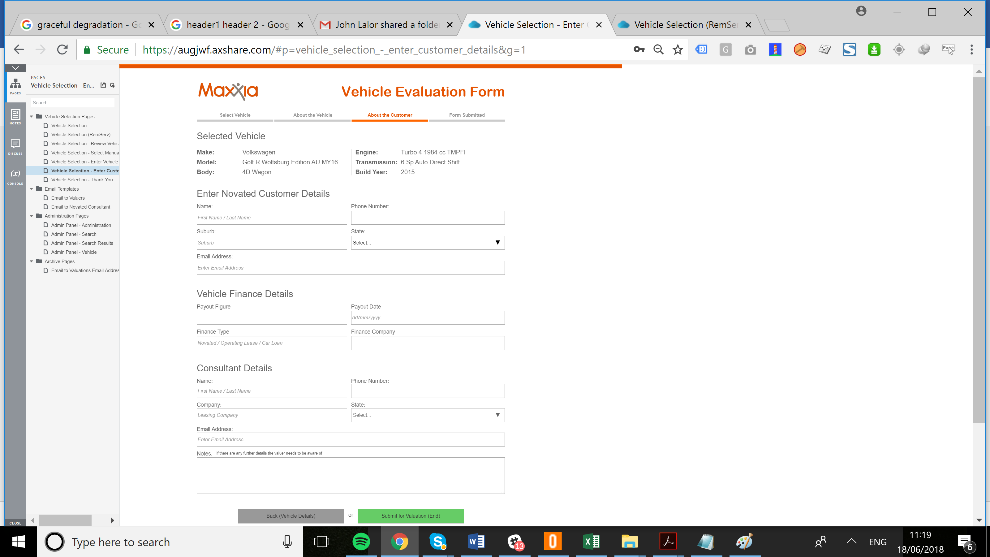

5.2

**Page**  
  
<https://augjwf.axshare.com/#p=vehicle_selection_-_select_manually&g=1>

### 5.1 Text

* Requirements for the Maxxia fonts are described on **pages 13 & 14**

|  |  |
| --- | --- |
| Header 1 <h1> | Selected Vehicle |
| Header2 <h2> | Vehicle Evaluation Form |
| Header3 <h3> | Enter Novated Customer Details, Vehicle Finance Details, Consultant Details |
| Title <title> | Maxxia – Customer Details |

### 5.2 Email Address

* Email address validation is required

## 6. Thank You

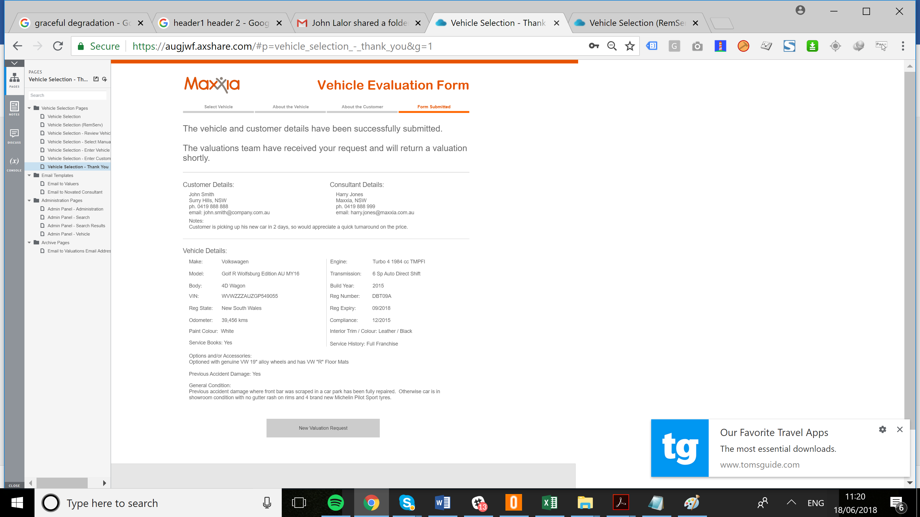

6.2

**Page**  
  
<https://augjwf.axshare.com/#p=vehicle_selection_-_select_manually&g=1>

### 6.1 Text

* Requirements for the Maxxia fonts are described on **pages 13 & 14**

|  |  |
| --- | --- |
| Header 1 <h1> | /None |
| Header2 <h2> | Vehicle Evaluation Form |
| Header3 <h3> | Customer Details, Consultant Details, Vehicle Details |
| Title <title> | Maxxia – Thank You |

### 6.2 Button Selection

* For “New Valuation Request” use Maxxia Orange



## 7. Admin Panel – Administration

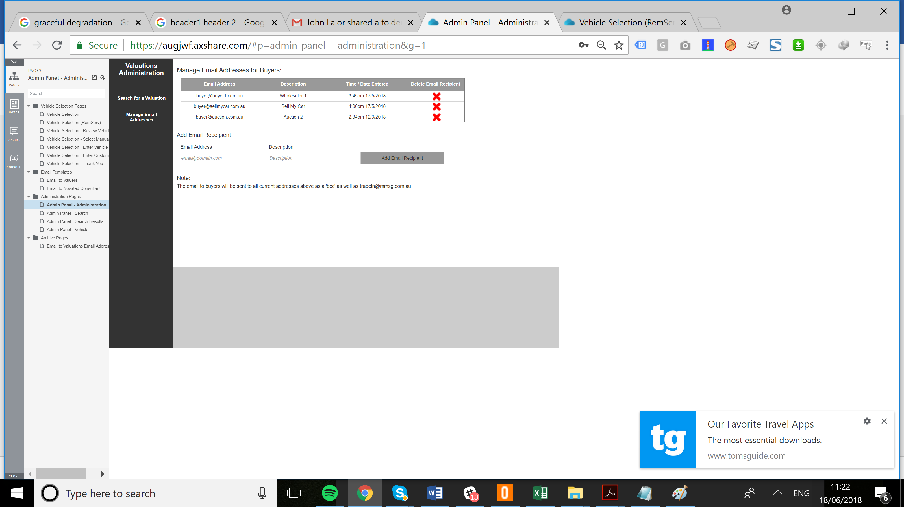

**Page**  
  
<https://augjwf.axshare.com/#p=vehicle_selection_-_select_manually&g=1>

## 8. Admin Panel – Search

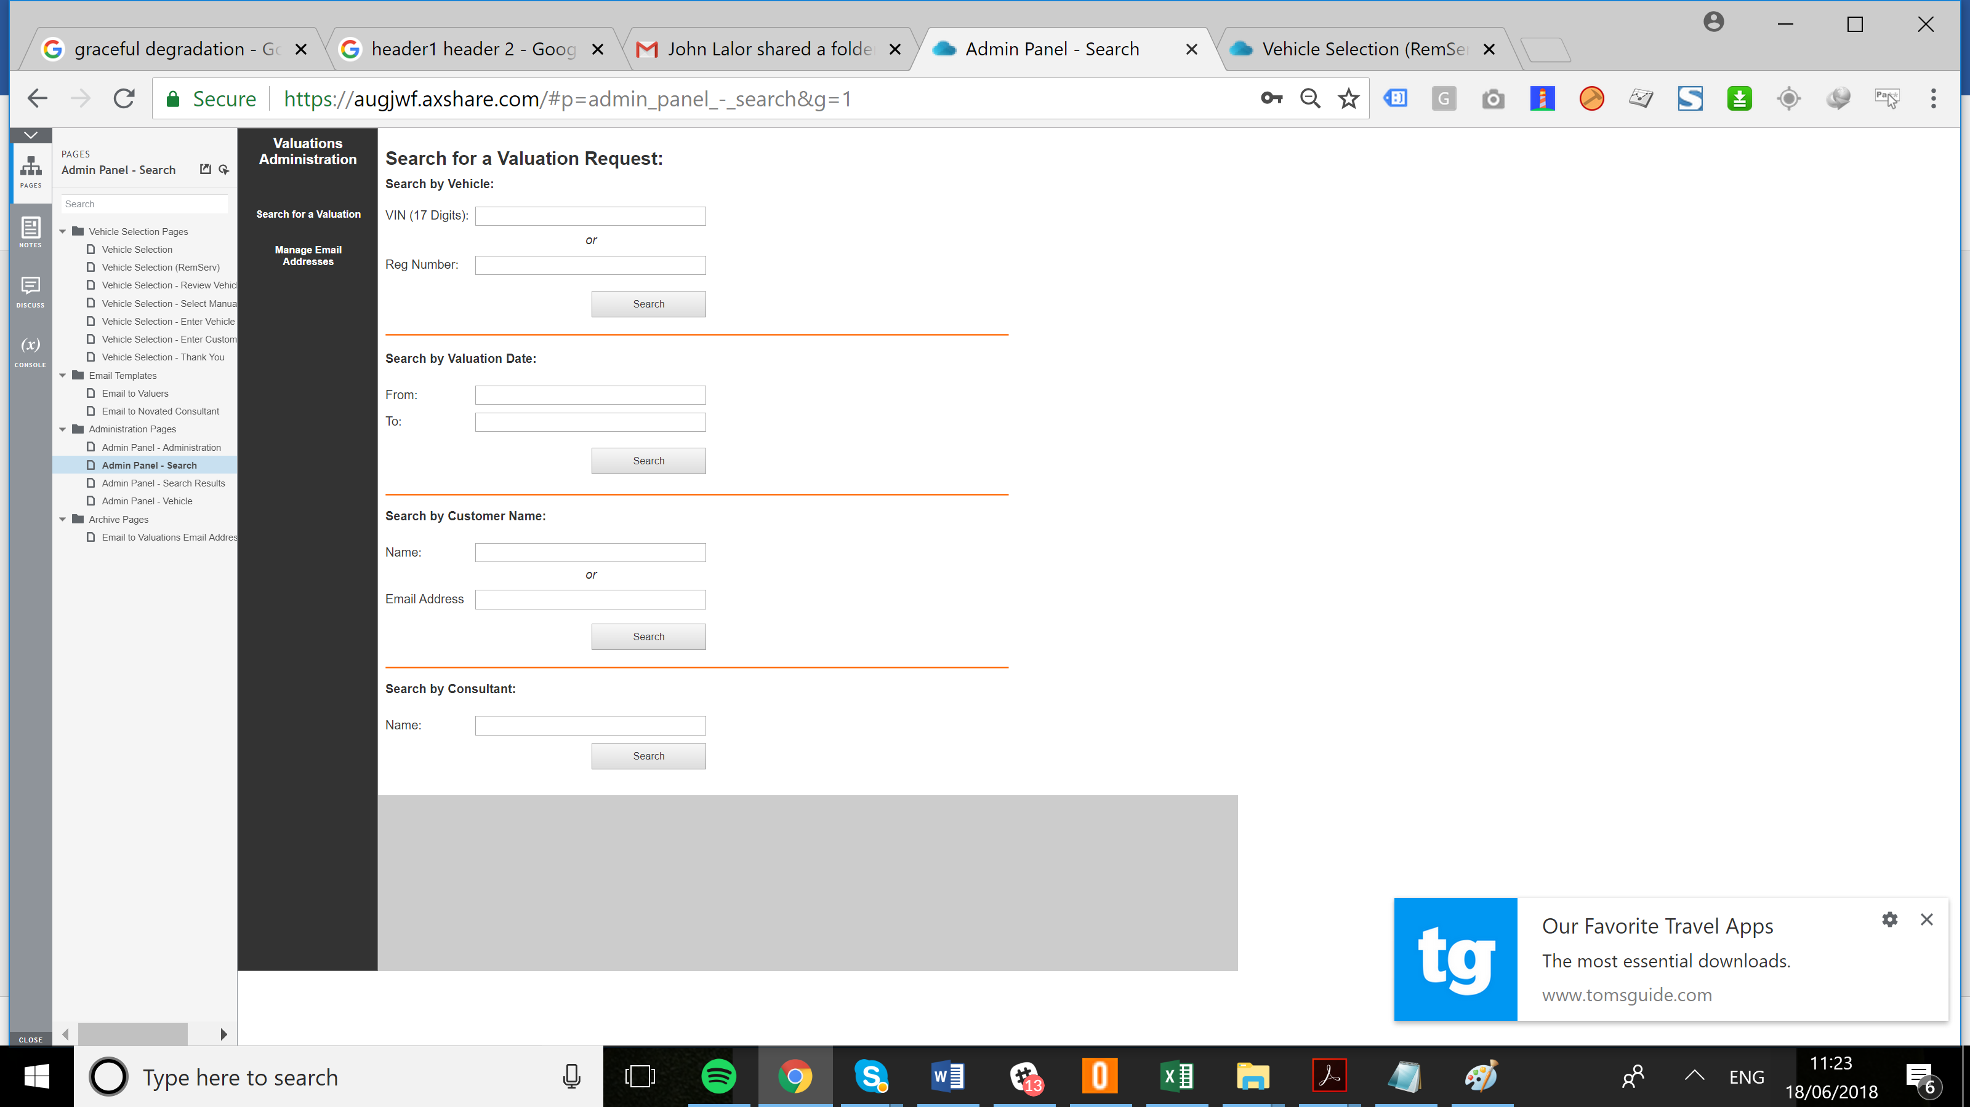

**Page**  
  
<https://augjwf.axshare.com/#p=vehicle_selection_-_select_manually&g=1>

## 9. Admin Panel - Search Results

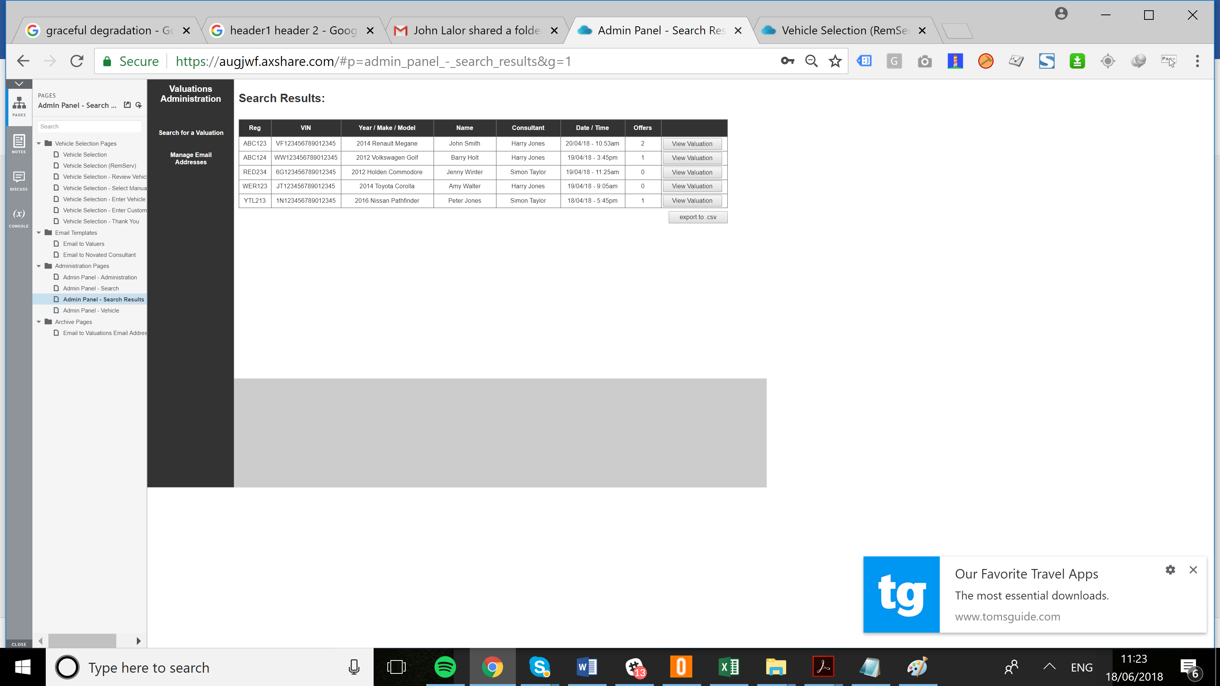

**Page**  
  
<https://augjwf.axshare.com/#p=vehicle_selection_-_select_manually&g=1>

## 10. Admin Panel - Vehicle

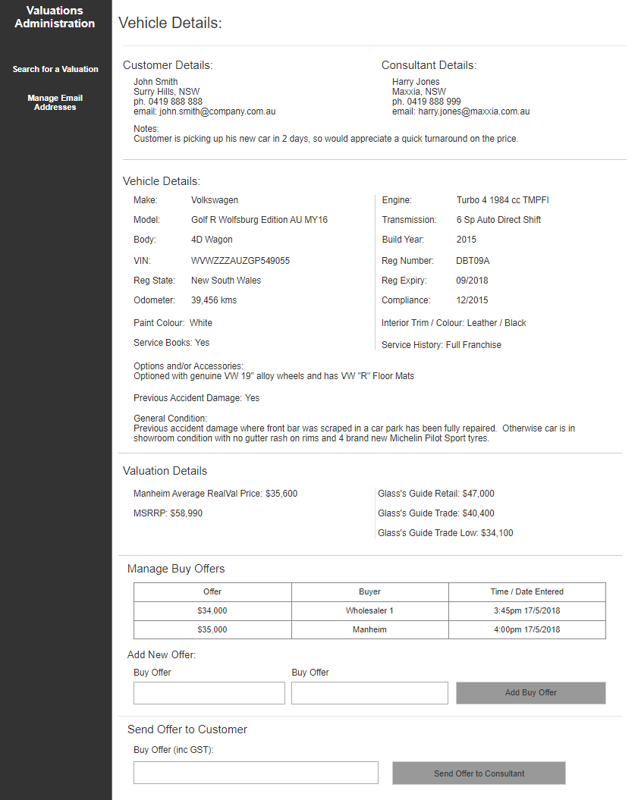

**Page**  
  
<https://augjwf.axshare.com/#p=vehicle_selection_-_select_manually&g=1>